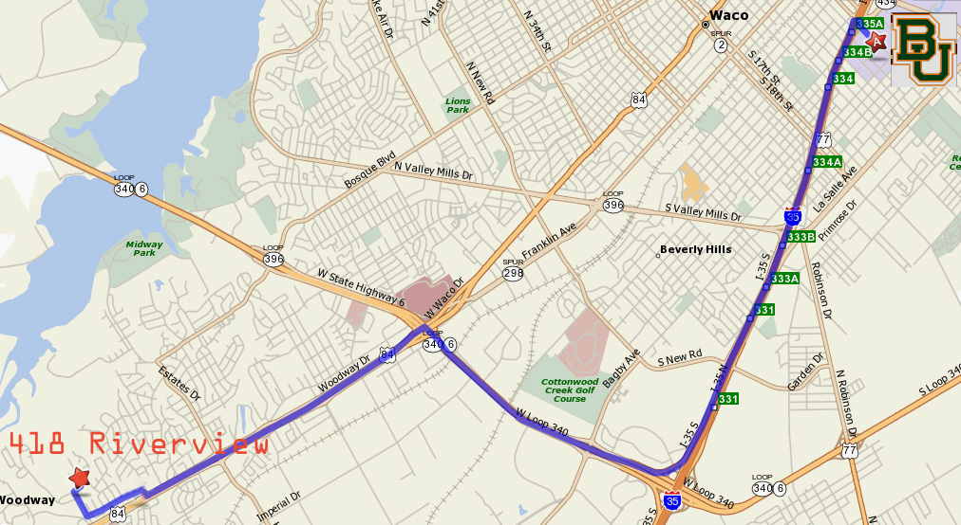
ZOOM IN:

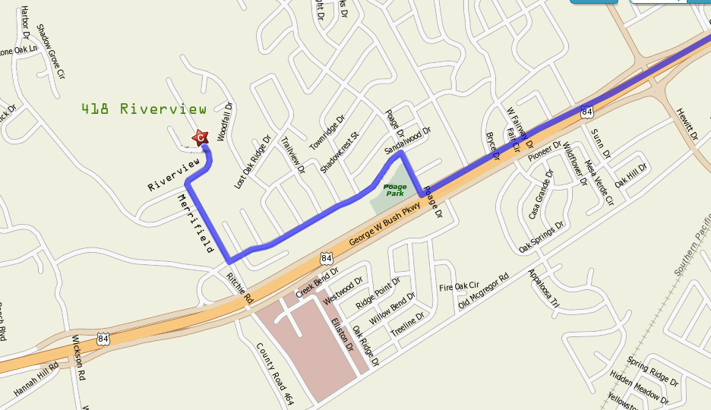

Directions to 418 Riverview Drive (254-776-1810):

WARNING: DO NOT USE GOOGLE MAPS, MAPQUEST, ETC., AS THEY WILL OFTEN SEND YOU TO THE WRONG “418 RIVERVIEW” IN NEARBY LORENA, TX

From I-35, intercept Loop 340/Highway 6 South of Waco (Central Texas Marketplace Shopping Complex (Best Buy…) is on your right). Travel West/NW on Loop 340/Highway 6 (TO YOUR RIGHT OFF OF I-35, IF YOU ARE DRIVING FROM DALLAS/BAYLOR).

Exit (RIGHT) at U.S. 84 (aka “Franklin Ave.”). Richland Mall is on the NW corner of this intersection and Whataburger will be on your right.

Turn West (LEFT) under Loop 340/Highway 6 and enter ramp onto US 84 (away from Waco) passing through most of Woodway.

Exit (RIGHT) at the Poage Exit (next exit past Estates/Hewitt Dr. Exit where HEB grocery store is on the left and Walgreens and CVS is on the right).

Turn RIGHT off of access road onto Poage (at stop sign), go ONE BLOCK (past park), and turn LEFT onto Sandalwood.

Go to the second stop sign (about ½ to ¾ mile) and turn RIGHT onto Merrifield.

At the dead end with Riverview Drive turn RIGHT. 418 Riverview will be on your RIGHT after a hard left curve in the street (the addresses start over at 400 at the curve).

Summary: I35 South (if coming from Dallas/Baylor);
Loop 340/Highway 6 – Northwest (Right);
US 84 West (Left);
Poage Dr. – North (Right);
Sandalwood – West (Left);
Merrifield – North (Right);
Riverview – (Right);
418 Riverview – on Right.

